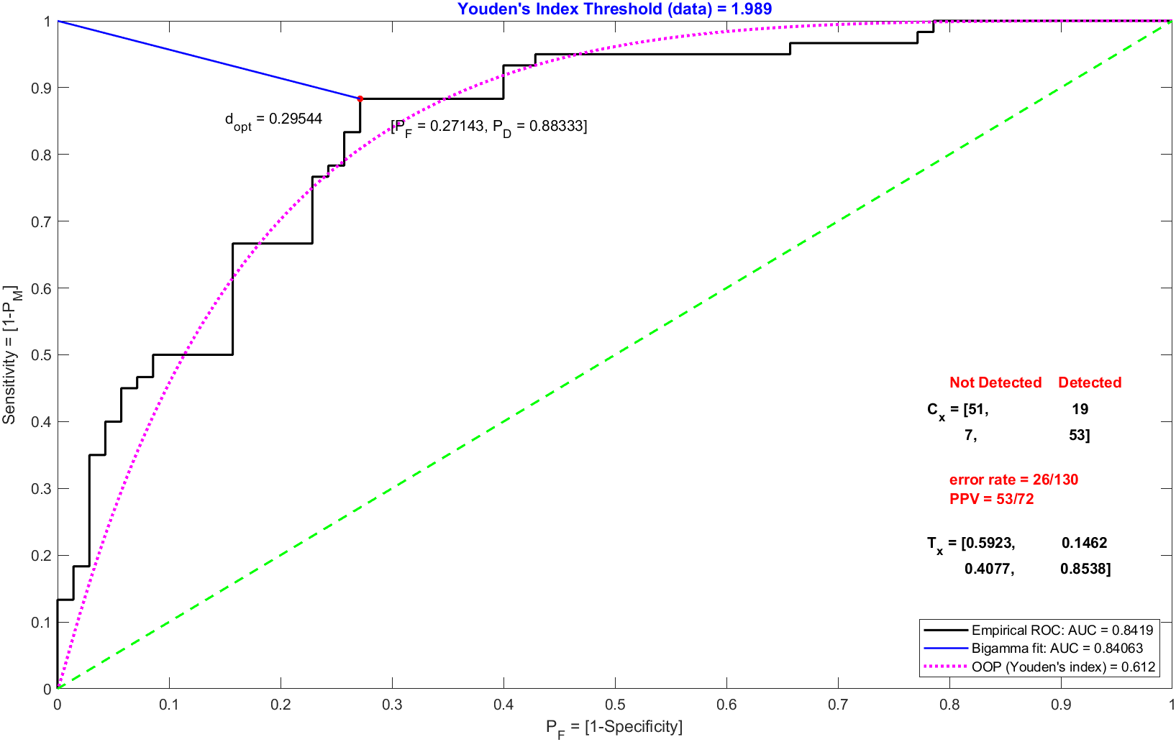

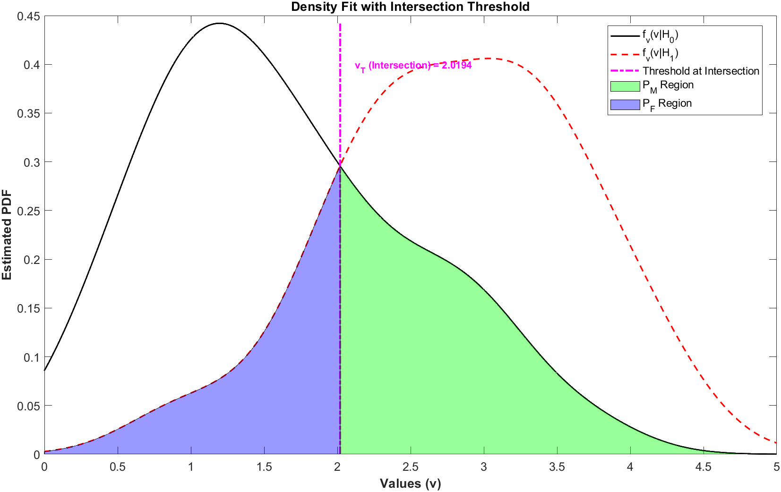

Based on the data, the optimal threshold values calculated from both the intersection point and Youden's index demonstrate effective separation between the "Target Absent" and "Target Present" classes, as shown by the ROC curves and the confusion matrices. The performance metrics, including error rates and PPV, indicate that both methods achieve comparable accuracy, though Youden's index provides slightly better sensitivity. Overall, the calculated performance index of approximately 1.0025 reflects a balanced and reliable classification outcome.